Problems Viewing Billing Statements

Depending on your browser and/or browser settings you may experience problems viewing your billing statements. This document will try to address most of the known issues.

Adobe Acrobat Reader DC will read PDF files

When clicking the View Selected Billing Statement link to view your statement:
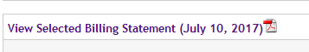

You may see the dialog box with the default “Open with” as TWINUI:

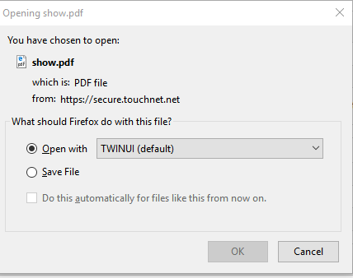

If you choose OK, you will see a “Please Wait ... ” message that will not dismiss.

Do not use the TWINUI default.
- Select the dropdown and choose “Other …”
- Select the first choice on that list, Adobe Acrobat Reader DC (See next page)
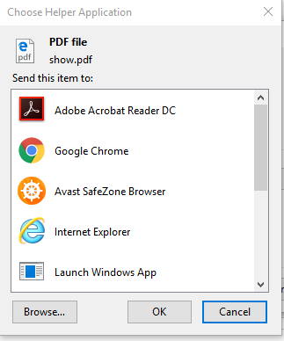

Choose Adobe Acrobat Reader DC and click OK. This will allow you to print your Billing statement.

Setting up browsers to read PDF files

The student population will have different operating systems and different browsers. The following link explains how to set up different browsers on different computer platforms for viewing PDF files:

https://helpx.adobe.com/acrobat/kb/pdf-browser-plugin-configuration.html

If you still cannot view your bill, please call the Bursar's Office for assistance at (610) 758-3160

