Instructions for Current Lehigh University Employees
to
Access Electronic W-2
provided by Lehigh University

Important: Only W-2s provided by Lehigh University may be viewed and printed from this site.

To access your W-2, proceed as follows:

Navigate to the Employee Self-Service tile on Connect Lehigh.

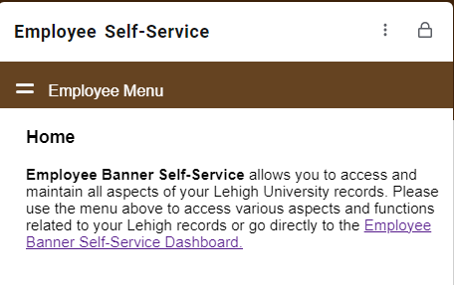
Select the tab labeled “Taxes”.

Select W-2 Wage and Tax Statement.

Select the applicable year and click Display.

