Purpose:

The Financial Analyst, Capital Asset Accounting is responsible for ensuring a physical inventory of University fixed asset equipment is performed on a bi-annual basis in accordance with University policy and OMB circular guidelines. The inventory will document the existence, description, location and date this information was provided.

Each building is inventoried on a bi-annual basis. A bi-annual physical inventory calendar is drafted at the beginning of each two-year period by the Financial Analyst, Capital Asset Accounting. This is a Google calendar titled “Inventory Calendar”. The calendar is compared against the University’s Location by running the Location Code Query which is located in the Property Management database to ensure that all buildings are included.

An MS Access Report Report\_phys\_inventory is run in the Access database located in **I:\Prop\Property Mgmt.mdb** (see Running Physical Inventory Reports for further instructions). This report lists the particulars about all of the equipment in a building, in building #, then room # order (The user is prompted to enter the building #. See **I:\Documentation\Prop Mgmt\Fixed\_Assets\_Location\_Codes.xls** for a listing of all of the Banner Building Codes).

The Financial Analyst, Capital Asset Accounting conducts the physical inventory by comparing the items on the reports against the actual item that is physically located. The Financial Analyst, Capital Asset Accounting coordinates the physical inventory process with lab technicians and departmental administrative assistants to locate items or to gain access to locked rooms. The Financial Analyst indicates on the form if the item has been found or is missing, its location, if different; and records any additional assets that have been found in that particular area; the condition of the asset and the date of the inventory. When the Financial Analyst finished conducting an inventory, he will sign off on the listing indicating that he has completed the inventory for that building. Then, he will have a representative from the department/building sign off as having witnessed him taking inventory

At the end of the physical inventory, the Last\_Inventory\_Date field in the FFAMAST form is updated with the inventory date. A follow-up is done to locate any items not located during the first pass.

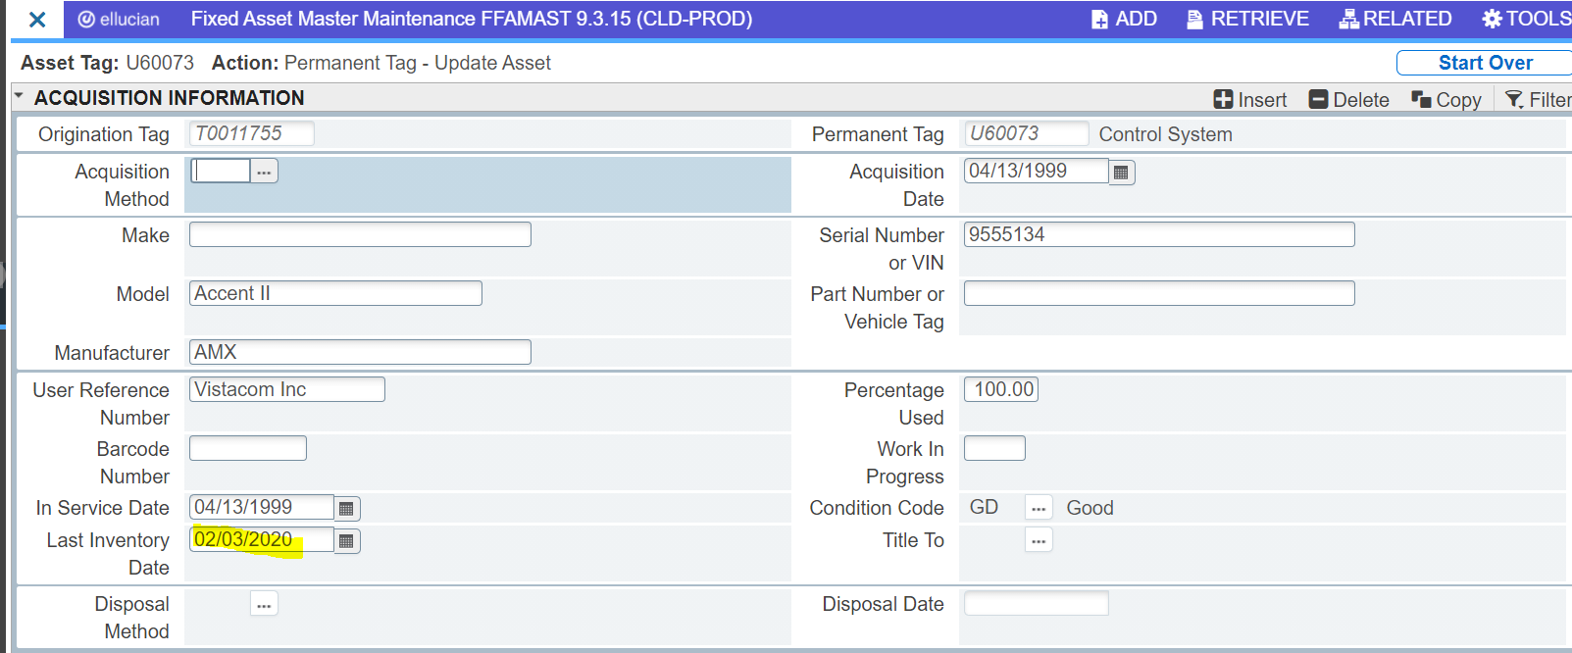

If a particular asset is not located, that is noted by using the FFAMAST form (Options, User Fields, User Attributes and selecting the appropriate INVENTORY Attribute). See User Defined Codes documentation for setting up attributes.

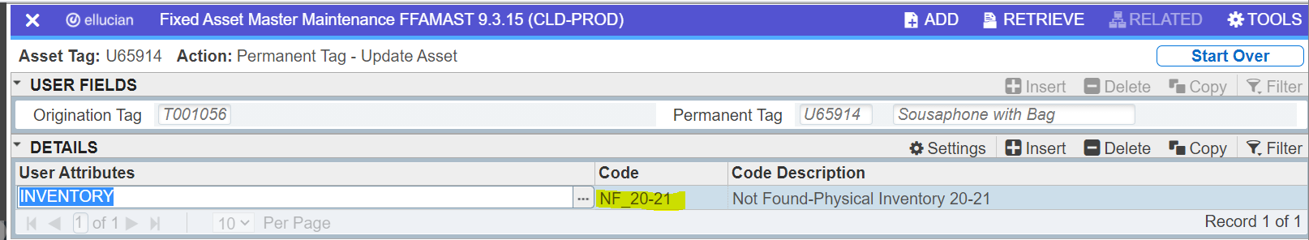

If a particular asset is not found, an MS Access Query is run, **I:\Prop\Fixed Assets.mdb\Not Found Inventory**. This prints out a report listing the particulars about the equipment that was not found in a particular building (a prompt appears for the user to type in the Building #). The inventory results are provided to the department lab technicians, administrative assistants and/or the department head requesting their assistance in locating the remainder of the items on the physical inventory.

After all efforts to locate missing equipment have been exhausted, items that have not been located will remain on the Fixed Assets database for another bi-annual physical inventory cycle since there is a possibility the item may be located at some other location on campus. If at the end of the second bi-annual inventory the items are still not located, they are disposed of. The custodian is asked to submit a disposal form <Disposal_form.doc> so the asset can be disposed. **Note**: If a piece of missing equipment is still missing after the second inventory cycle and it was originally purchased with federal funds, Research must be notified of its pending disposal and approve the disposal.

If the location code of a particular asset has changed, the location is changed using the FFATRAN form (**O**ptions, **T**ransfer Information). The record in Banner is updated by the Financial Analyst and verified by the Financial Analyst during the review process.

The individual listings for each building are located in the Financial Analyst’s current file folder (paper file) while he is working with them. After he is finished updating Banner, he will submit the listing to the Financial Analyst who reviews the inventory results by running the access query qry\_Inventory Recap\_w custodian\_ISH which is located in the Fixed Asset Database and exported to excel and compared with the inventory count sheets prepared by the inventory analyst. This monitoring assures that the physical inventory is being conducted in a timely manner, assures that all changes in location have been recorded in Banner, follow up activities have been performed, and assures that the buildings are inventoried within the two-year cycle. After review, the Financial Analyst will sign off that the buildings have been inventoried and updated in Banner accordingly. After the Financial Analyst has reviewed the inventories, they are forwarded to the Assistant Controller for review. The listings are then filed in the current cycle inventory file folders organized by building name in the filing cabinet located in the files across from the Financial Analyst’s desk.

An updated inventory listing is sent to each custodian after the inventory has been completed and reviewed for a particular building. This report is sent according to the predetermined inventory completion dates on the inventory calendar by the Business Intelligence Team. The Financial Analyst, Capital Asset Accounting is responsible for updating the listing of completion dates according to the building at the start of the new inventory cycle and informing the Business Intelligence Team by submitting an LTS Ticket.

Employee termination notices are sent to the Financial Analyst, Capital Asset Accounting from the payroll office. The query Custodian search w/Index and cost\_JAT is run by the Financial Analyst to determine if the employee leaving Lehigh is the custodian for any assets. If they are determined to be a custodian, the query is exported to excel, printed and attached to the termination notice. The Financial Analyst uses the listing to have Banner updated with the new custodian.

Beginning 3/17/2020 there was no access to the buildings during the Covid-19 Pandemic. The actual physical inventories were not able to be taken. As a result of this the building listing was run by the Financial Analyst & sent to the Financial Analyst to update the user defined field as shown below. 