Consent required to receive W-2’s electronically
Step 1. Locate the Employee Self-Service tile via Connect Lehigh.
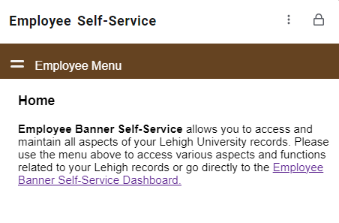
Step 2. In the middle of the Dashboard, select the taxes link:
Step 3. Again, in the middle of the Dashboard, select Electronic Regulatory Consent:
Step 4. Check the box under My Choice and select the Submit button. All done!

