The Desktop Finance Reporting database is a Microsoft Access database designed to provide user-friendly access to Banner Finance and related reports and financial data.

This database is maintained by Bob Siegfried, Director of Finance and Administration Systems, and is available to all Banner Financial Managers and their designees.

To request access, simply send an email request to rs08@lehigh.edu.

If you do not already have access to Banner Finance, you also need to complete a Banner Access Request Form available at http://www.lehigh.edu/~inctr/docs/RequestforBannerFinanceAccess.doc.

Once access is approved, you will be issued a Banner password which is required to login and use the Desktop Finance. You first need to copy the database from the directory J:\banner\DesktopFinance. The database naming convention is “Desktop_Finance_dmrt_mmddyy.mdb” where mmddyy indicates the date of revision. The database is updated periodically and users are notified by email when enhancements are made.

The database requires Microsoft Access. You may also need to install Oracle on your pc and create ODBC connections to the Banner datamart (dmrt), however most University pc’s are set up with Oracle already installed. If you’re not sure, contact your LTS desktop computing consultant for assistance.

The Banner datamart is a copy of the Banner production system that is re-created every night, so that all reports are as current as the night before.

Please note that the Desktop Finance Reporting database provides an online electronic filing cabinet of all monthly hard copy reports currently distributed by the Controller’s Office. It is hoped that this reporting database will replace the need for hard copy report distribution. When you’re ready to cancel your hard copy reports, please contact Cindy Hickman in the General Accounting Office at 83204 or via email at cmh3@lehigh.edu.

As mentioned above, the Desktop Finance Reporting database was designed to be very user-friendly. All reports are simply a mouse click away and only require end users to select simple parameters such as fiscal year, fiscal period, Banner Index, organization code, etc

A word about organization codes… the Desktop Finance Reporting database provides various forms of roll up reporting by Vice Presidential stem, College, Department, Center, Institute, or administrative area of the University. Reports by org code require the user to select a 2, 3 or 4 digit org code. If you are unsure of the org code for your area, please contact Cindy Hickman or myself.

Questions about installing or using the database in general, or any specific reports, can be directed to Bob Siegfried at 83142 or by email at rs08@lehigh.edu.

The Desktop Finance Reporting database was designed to be a dynamic, end user tool, constantly changing to meet end user needs for managing financial information. Requests for enhancements, changes, new reports, etc. are always welcome and should be directed to Bob Siegfried.

The following pages include screen shots of all menus and descriptions of reports.

Logging in…

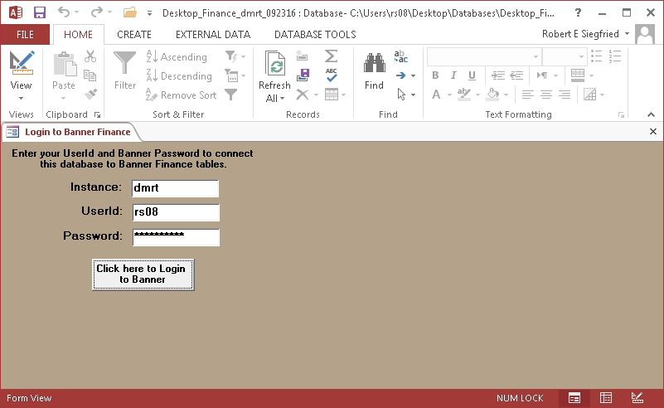

This is the login screen that will appear after you click on the “Desktop_Finance_mmddyy.mdb” icon on your pc’s main screen or desktop. Enter your Lehigh user ID and “Banner password” (note your Banner password may be different than the password you use to log onto Lehigh’s network).

Click on the box labeled “Click here to Login to Banner”. It may take 30 seconds or so to login while the database links to several tables in the Banner database.

Once login is complete, the main menu will appear below…

The Main Menu…

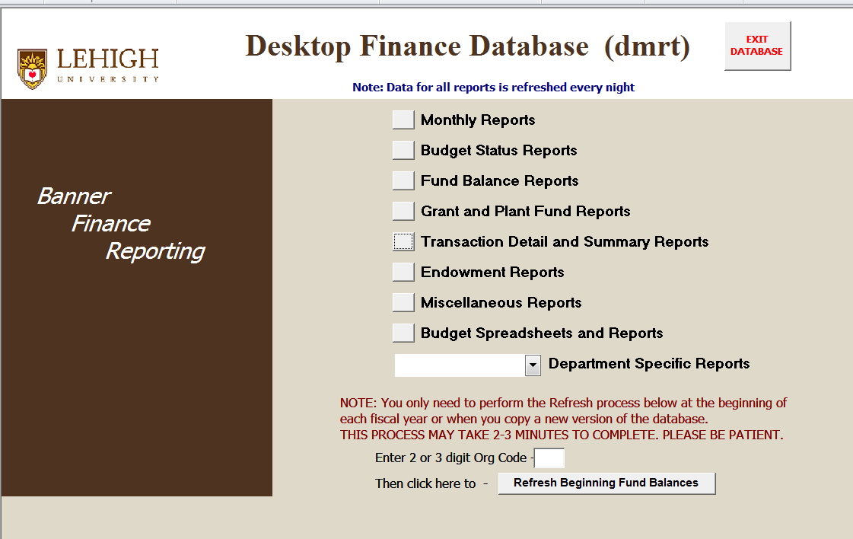

This is the main menu for the Desktop Finance Reporting database. By simply clicking on a menu item, you will access a submenu of various reports that will assist you in managing your University finances.

The Refresh Beginning Fund Balances button need only be used when a new version of the database is copied to your desktop or main screen of your pc. This process builds a table of beginning fund balances that are included later when Budget Status Reports are run for Banner Indexes that begin with 3, 4, 6 or 9. It also builds a list of all the Banner Indexes you have access to that you can select from later to run reports. If you notice any Indexes that are missing, you should contact General Accounting at 84549 or 83204.

Note that the Monthly Reports menu is listed first above because it is likely that most users can get everything they need to manage their Indexes from this first menu of reports.

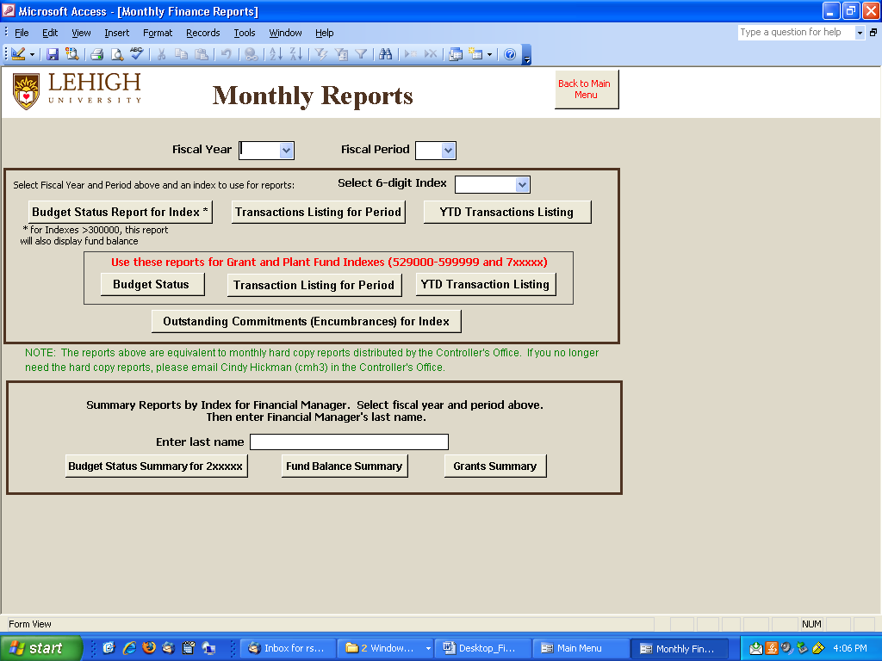

As mentioned earlier, the Monthly Reports menu is listed first because it is likely that most users can get everything they need to manage their Indexes from this first menu of reports.

The Monthly Reports menu is designed to replicate (and hopefully replace) the monthly hard copy financial reports distributed by the Controller’s Office. And, as noted above, it provides an online electronic filing cabinet of these reports for any fiscal year and monthly period you desire.

To run reports, simply use the drop down boxes to select a Fiscal Year, Fiscal Period, and Index.
The first three reports provide the Budget Status of an Index (including fund balance for Indexes beginning with 3, 4, 6, or 9), a Transaction Listing for Period (or month), and a Year-To-Date (YTD) Transaction Listing.

An identical set of reports is provided for Grant and Plant Fund Indexes (529000-599999 and 7xxxxx). Remember that Grant and Plant Funds are managed over the entire project period, which may overlap multiple fiscal years, therefore, budgets and expenditures are accumulated and reported from the beginning of the project. The project period is displayed on the Budget Status report for these Indexes.

The Outstanding Commitments (Encumbrances) for Index report lists the balance of payroll salaries to be paid from the Index through the end of the fiscal year and the balance of any open purchase orders.

The Summary Reports at the bottom of this menu provide Financial Managers with three distinct lists of their Indexes… the Budget Status Summary for 2xxxxx report lists the summary budget status of Indexes funded by the university budget; the Fund Balance Summary lists the fund balance of Indexes beginning with 3, 4, 6, or 9; and the Grants Summary report lists the summary budget status of Grant and Plant Fund Indexes in the range 529000-599999 and 7xxxxx (reported on a cumulative or project-to-date basis).
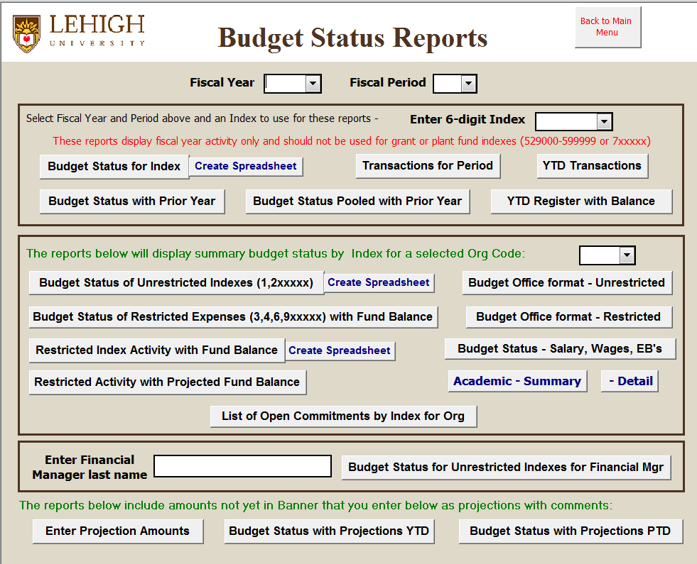

The first block of reports on the Budget Status Reports menu replicates the first three reports on the Monthly Reports menu. These should not be used for Grant or Plant Fund Indexes in the range 529000 to 599999 or 7xxxxx. A separate main menu item is provided for Grant and Plant Fund Indexes.
The YTD Register with Balance report displays Banner financial activity in the format that resembles a check register, listing all transactions from the beginning of the fiscal year followed by a summary that displays either the budget balance or fund balance (for Indexes beginning with 3, 4, 6 or 9).

The second block of reports will list the summary budget status of all Indexes associated with a specified 2, 3 or 4-digit org code (for VP, College or Department) and are excellent management type reports for Deans, Department Heads or Business Managers. Note that there are separate Budget Status reports for Unrestricted and Restricted Indexes and some can be created as Excel spreadsheets for further manipulation. Reports for Restricted Indexes also display fund balance. Reports labeled “Budget Office format” display separate columns for Revenues, Salaries and Other Expenses. The last report in this block lists all open commitments or encumbrances for an organizational unit.

The report Restricted Activity with Projected Fund Balance includes a projected fund balance for endowment spending accounts (45xxxx) calculated by including the annual budget for endowment income in the projected fund balance (rather than only what has been distributed to date).

You can also run the Budget Status for Unrestricted Indexes for Financial Mgr report by simply entering a Financial Manager’s last name. Remember though that names in Banner are case sensitive.
Budget Status reports with projections –

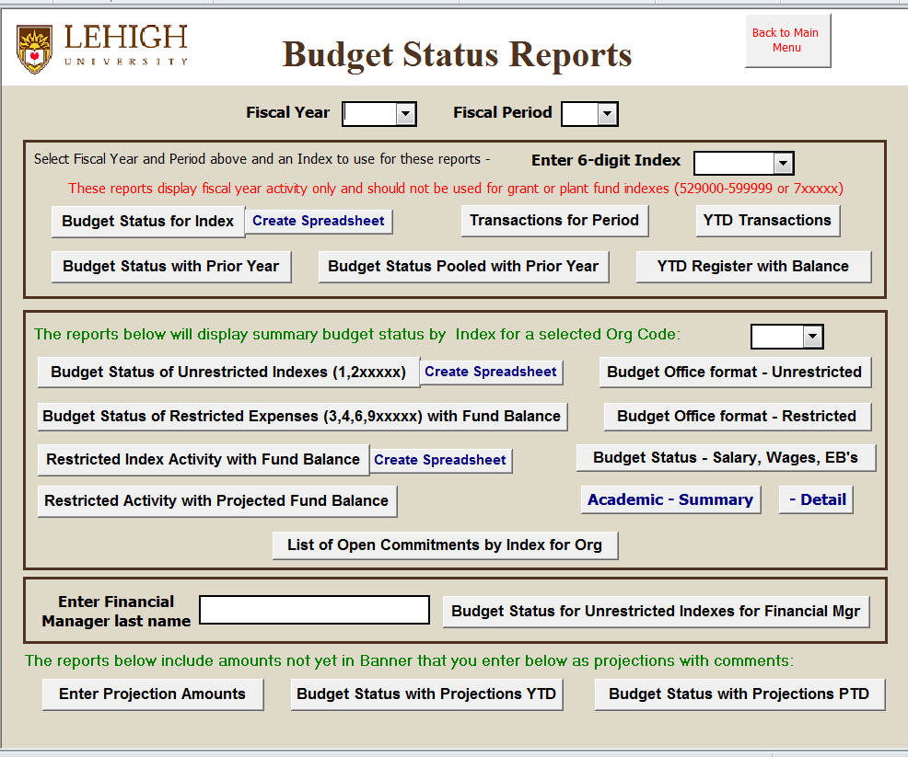

You can now enter projections for specific Indexes and Account Codes for planned or estimated revenues or expenditures, or for items not yet entered in Banner, and then include them on Budget Status reports. Your projections will be listed in a separate column on the report along with your comments or descriptions of the projection amounts.

Use this report to include projections for grant funds

Use this report for all other Indexes

After you click on Enter Projection Amounts above, you will be prompted to enter an Index, then prompted to log into Banner production (where your projections are maintained), and finally a form will open into which you can enter your projection amounts and any related comments to describe or explain the basis for your projections. The UserID and Date fields are optional. See series of screen prints on the next page…

Enter the Index for which you want to enter or view projections…
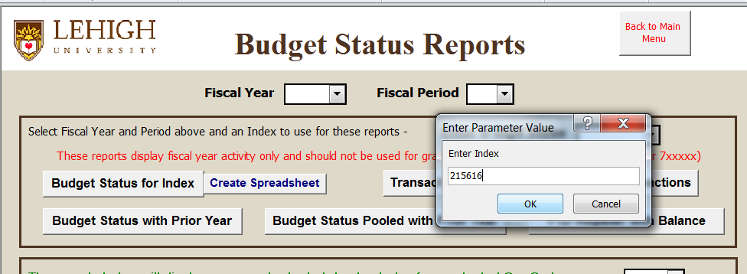

Log into Banner Production where projections are stored…
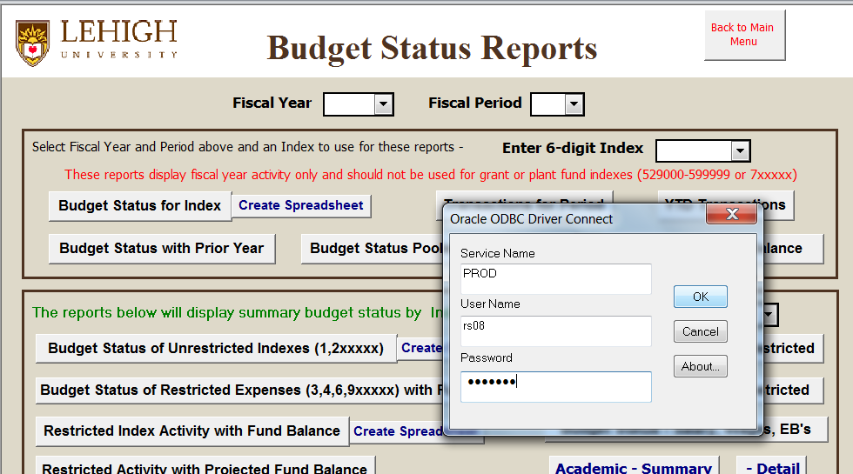

Enter your projections and related comments. UserID and Date are optional.
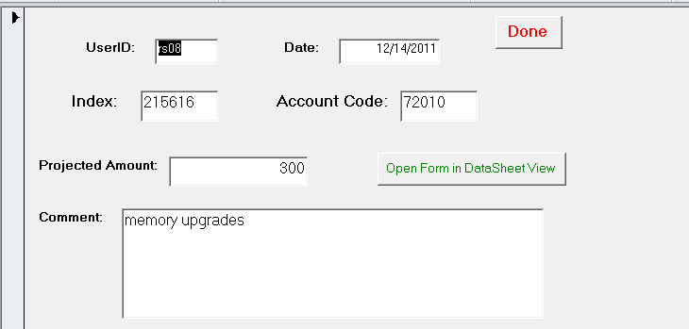
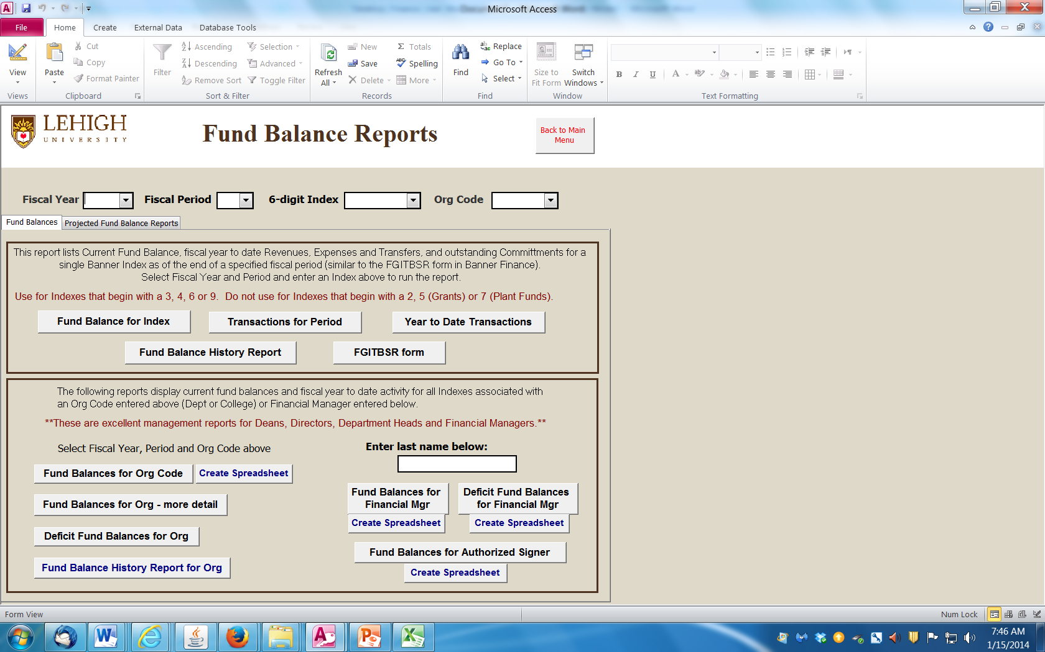

Please note that this menu item has two tabs.

The first tab labeled “Fund Balances” includes Fund Balance reports for a single Index that display summary or year-to-date activity and current fund balance for Indexes that begin with 3, 4, 6, or 9. These reports are similar to Banner forms FGITBSR and FGIGLAC. The Fund Balance History Report provides summary fund balance and activity by fiscal year for prior years.

Note that Fund Balance reports are not designed for Grant or Plant Fund Indexes in the range 529000 to 599999 or 7xxxxx. These Indexes should be managed solely on budget status. Please use the main menu item Grant and Plant Fund Reports for these Indexes.

The second block of Fund Balance reports list summary fiscal year activity (beginning fund balance, revenues, expenses, transfers, commitments and ending fund balance) for all Indexes associated with an org code selected at the top of the form. 2, 3 or 4-digit org codes can be selected to group Indexes by VP, College or Department, or you can group by entering a Financial Manager’s last name. Click on “Create Spreadsheet” if you wish to review the report in Excel and manipulate further as needed.

“Deficit Fund Balance” reports are exception reports that list only Indexes that have a negative or deficit current fund balance. These Indexes generally require immediate attention.

The second tab labeled “Projected Fund Balance Reports” is displayed and explained below…

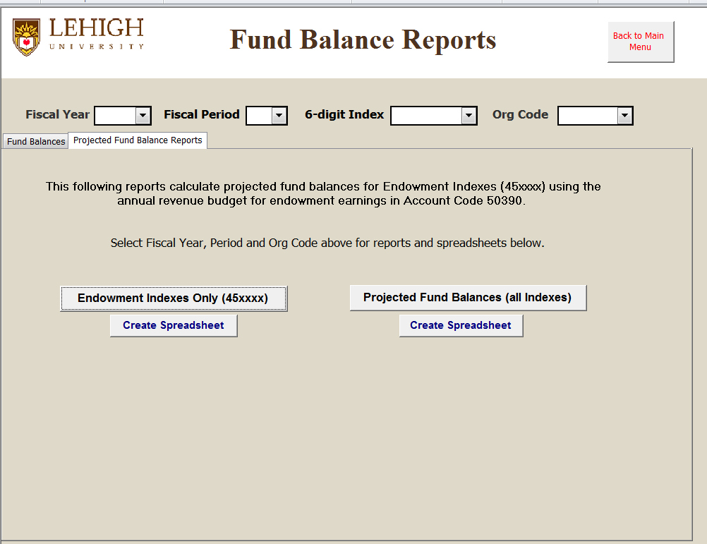

Both reports on this tab calculate projected fund balances as of the end of the current fiscal year based on the total amount budgeted for endowment earnings, rather than just the earnings that have been recorded through the current monthly period.

Banner distributes amounts budgeted for endowment earnings (in account code 50390) at the rate of 1/12 each month, however, salary commitments are generally recorded for the entire fiscal year. These reports also calculate employee benefit costs based on the current salary commitments recorded in each Index. The result is a projected uncommitted fund balance as of June 30 of the fiscal year, assuming all endowment earnings have been recorded and all commitments (including salaries and benefits) have been paid.

Both reports can also be displayed in Excel for further manipulation by clicking on “Create Spreadsheet”.

The “Endowment Indexes Only (45xxxx)” report includes only endowment spending Indexes that begin with 45.

The “Projected Fund Balances (all Indexes)” report includes all Indexes that begin with 3, 4, 6, or 9.

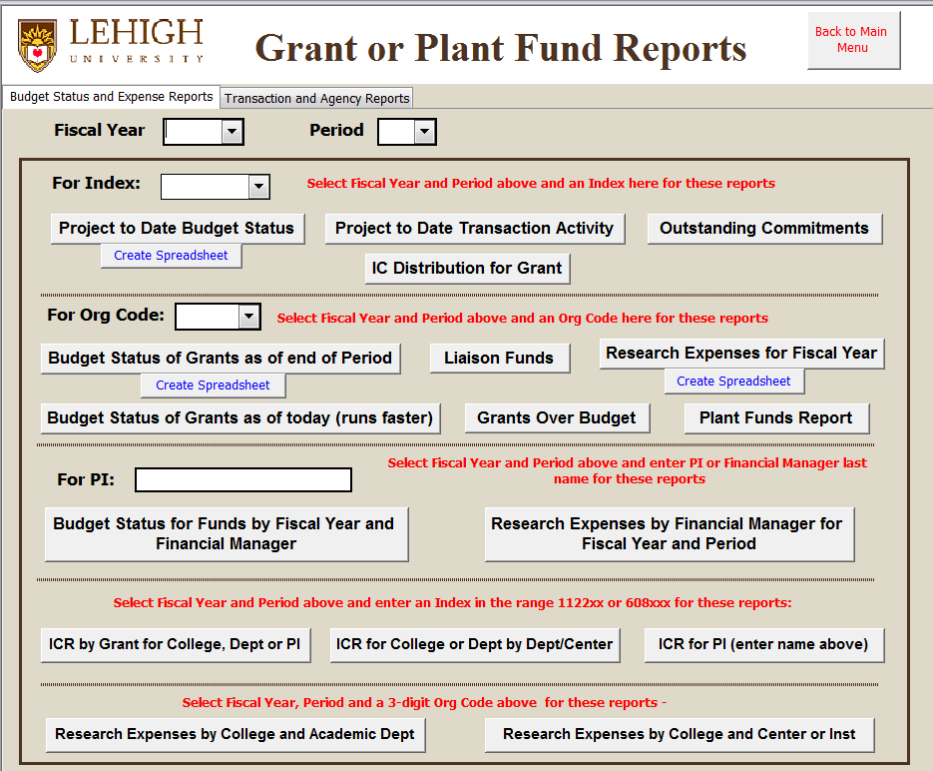

The Grant or Plant Fund Reports menu also has two tabs. These reports are specifically designed to report financial data on a project-to-date basis (rather than fiscal-to-date) for Grant or Plant Fund Indexes in the range 529000 to 599999 or 7xxxxx. Project-to-date (PTD) reporting is cumulative reporting from the inception of the grant or plant fund project and generally overlaps multiple fiscal years.

The first set of reports is for a single grant or plant fund Index.

The second set of reports will list the summary budget status of all grant and plant fund Indexes associated with a specified 2, 3 or 4-digit org code (for VP, College or Department) and are excellent management type reports for Deans, Department Heads or Business Managers.

The third set of reports will list the summary budget status of all grant and plant fund Indexes associated with a Financial Manager or Principal Investigator (PI). Simply enter the last name of a Financial Manager or PI and remember that names in Banner are case sensitive.

The “ICR by PI and Grant for Index” report will list the sources of indirect cost recovery (individual grant funds) recorded each month in Indexes in the ranges 1122xx or 608xxx.

The last two reports of Research Expenditures by College will summarize grant fund expenses by attributes assigned by Research Accounting for Academic Dept and Center affiliation.
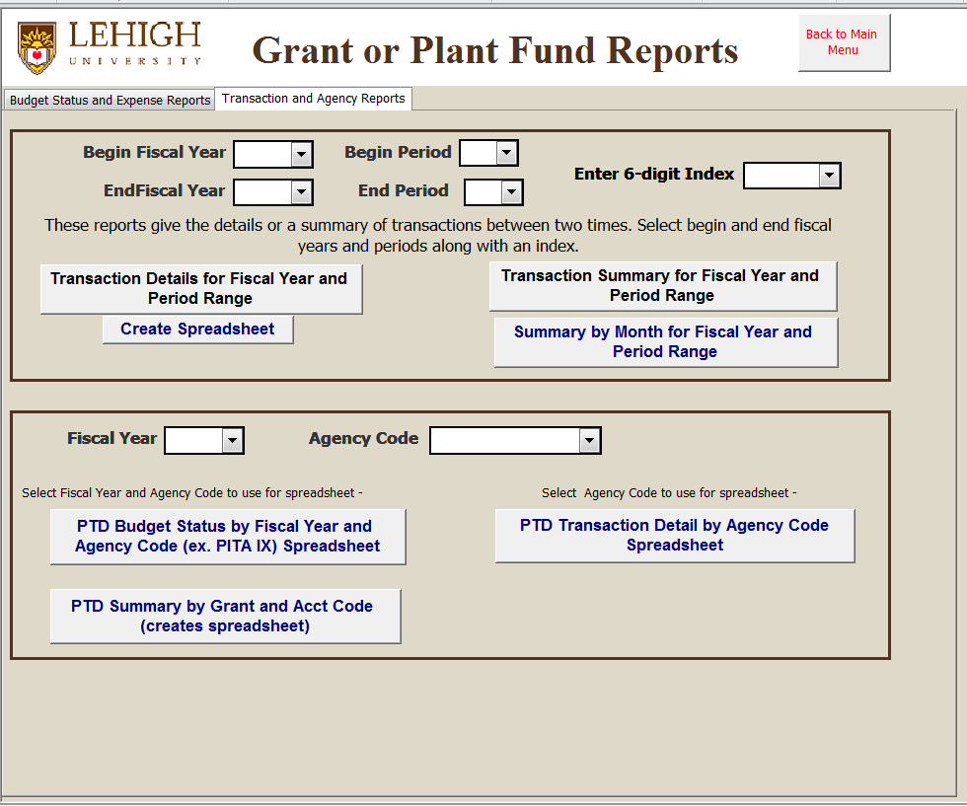

The second tab on the Grant or Plant Fund Reports menu provides various ways to report transaction activity for grant and plant fund Indexes for whatever range of fiscal years and monthly periods you need. These reports can be particularly useful if you need to prepare billings on anything other than a single monthly period (such as bi-monthly, quarterly or a calendar year basis).

A report of transaction activity for all fiscal years and periods is also very useful for reviewing project-to-date transactions for a grant or plant fund project that may overlap several fiscal years.

Note that you can produce both a list of Transaction Details and a Transaction Summary for the same fiscal year and period range.

Finally, you can create a report in Excel spreadsheet format that will summarize activity by month for the fiscal year and period range selected.

The second block of reports summarize activity for selected agency codes used in Banner to group certain grant funds by the granting agency.
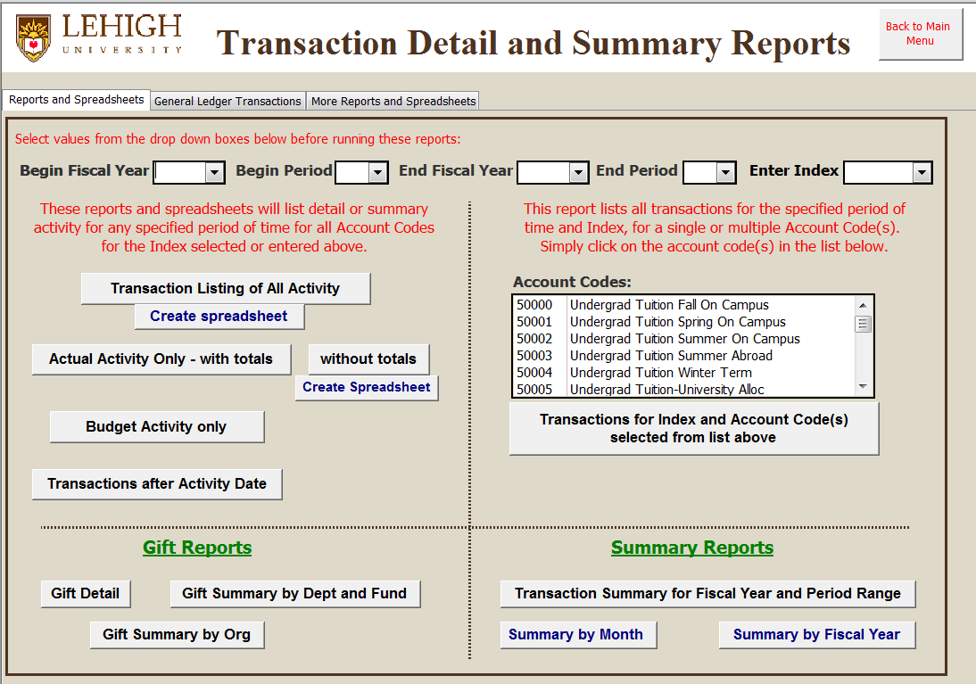

Note that the Transaction Detail and Summary Reports menu has three tabs.

The first tab of transaction reports allows you to select single or multiple fiscal years and periods or any range thereof. On the left, you can generate various reports of transaction activity for any Banner Index. On the right, you can generate a report of transactions for single or multiple account codes for an Index.

Reports of “All Activity” will include separate columns of activity for Budget, Actual and Commitments. You can create reports of “actual only” activity either with subtotals by account code or without. And you can create some reports directly in Excel format by clicking on “Create Spreadsheet”.

The report labeled “Transactions greater than Activity Date” is useful for reviewing transactions against your Index after a certain date, for example, after a monthly or fiscal year end.

Gift Reports include a detailed listing of gift transactions or summary reports of gifts by Dept or Org Code.

Summary Reports can be very useful for summarizing activity for an Index by month or by fiscal year for whatever range of fiscal years or monthly periods you select at the top of the menu.

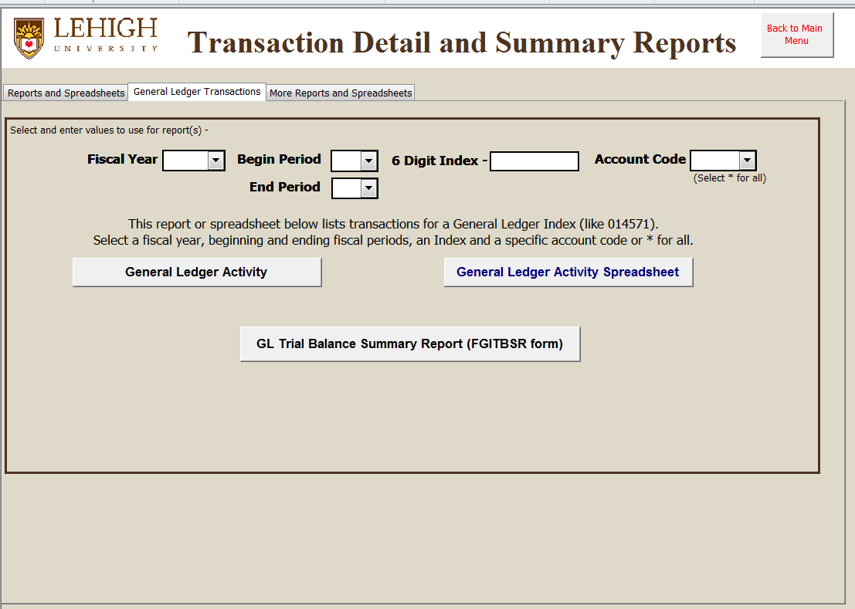

The tab labeled General Ledger Transactions is designed to assist users who need to monitor activity in deferred revenue and expense Indexes (like 0145xx) or some Endowment or Plant Fund Indexes (05xxxx or 07xxxx). The 014xxxx Indexes are generally associated with summer programs where activity generally overlaps fiscal years.

These reports are also useful for departments like the Bursar’s Office, Controller’s Office or Human Resources where staff are responsible for reconciling various Banner Indexes used to record deposits, advances, receivables, payroll deductions, accruals, deferred revenue and various payables.

Users have the choice of generating a report or creating the output in an Excel spreadsheet for further manipulation.

The report “GL Trial Balance Summary Report (FGITBSR form)” is equivalent to the Banner form FGITBSR.

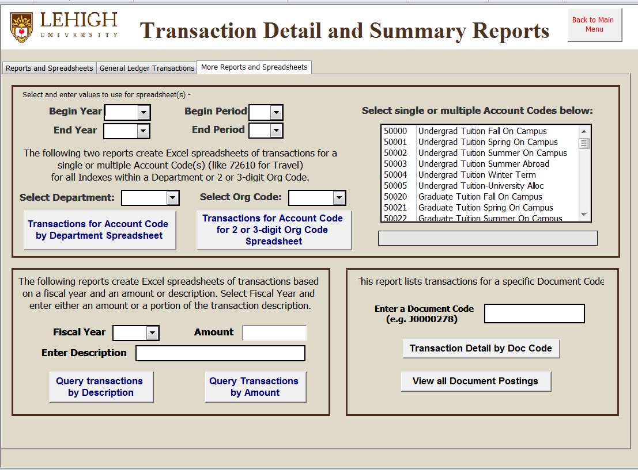

The third tab of Transaction Detail reports allows the user to create reports of transaction activity for all Indexes associated with a 2, 3, or 4 digit org code (VP, College, or Dept). So for example, if you wanted to review all travel activity for your department for a fiscal year or range of monthly periods, you simply select the beginning and ending fiscal year and periods, select your Department or other Org Code, select single or multiple account codes, and then click the report for Department or other Org Code. The results for these reports will be displayed in an Excel spreadsheet.

The next block allows you to query a transaction by the description or some part thereof. If for example you recall receiving a check from a company or making a purchase from a certain vendor but you can’t remember what Index was used, this report may help you find it. One caution though is that the search may take a minute or two while it searches all the transactions in all the Indexes you have access to.

The last block on this tab allows you to list all the transactions associated with a Banner document code (like a journal entry J0000278). This can be helpful when reviewing activity like transfers between Indexes… you may see the charge or credit in one Index and would like to know where it went or came from. Note this only works if you have access to both Indexes.

The “Transaction Detail by Doc Code” report is also useful for querying the Indexes charged on a purchase order or invoice. Simply enter the PO number (like P0012345) or the voucher number for an invoice (like I0012345).

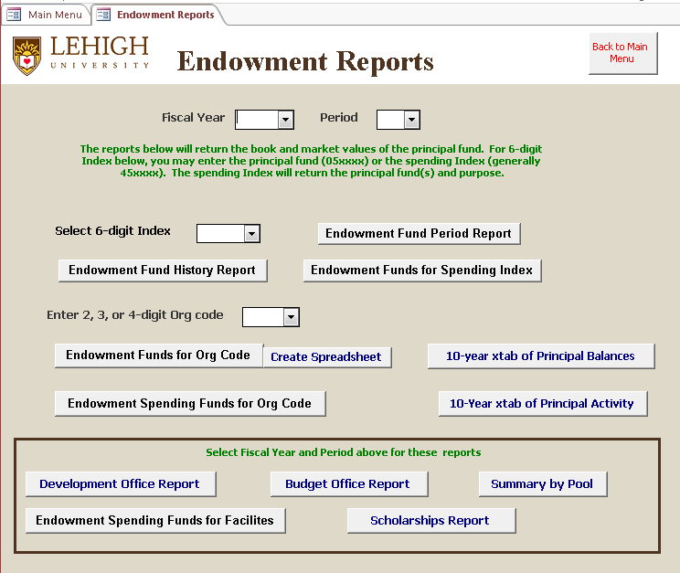

The Endowment Reports menu provides information about Indexes funded from endowment revenue (generally Indexes in the range 45xxxx).

Information displayed includes the related endowment principal funds, along with their book and market values and number of units both currently and at the beginning of the fiscal year. Also displayed is the purpose for which the income can be used.

If you select a 6-digit Index, you can run the Endowment Fund Period Report for the specific month selected above, or you can run the Endowment Fund History Report which will provide summary information for that fund for several fiscal years.

If you select a 2, 3 or 4-digit Org code, you will get a report of all Indexes funded from endowment for an organizational unit.

The reports labeled Development Office, Budget Office, and Summary by Pool are designed to meet specific needs of these departments. You may run them out of curiosity but they will only include Indexes for which you have access.

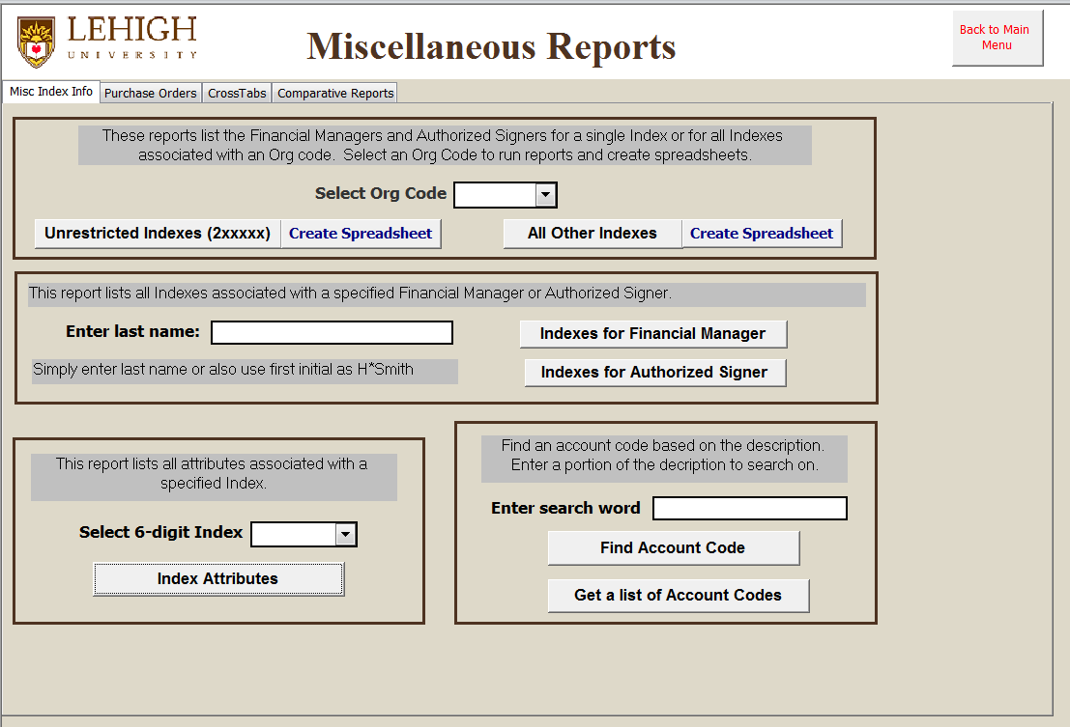

Note that the Miscellaneous Reports menu has four tabs.

The first tab is labeled “Misc Index Info”.

The reports in the first block create lists of Financial Managers or Authorized Signers for Indexes associated with a selected org code.

The reports in the second block create lists of Indexes associated with a Financial Manager or Authorized Signer.

The third block includes a report of “Index Attributes” that lists all the attributes associated with an Index including Authorized Signers, user id’s of persons receiving monthly hard copy report distribution, and several other attributes assigned to an Index by the Controller’s Office for reporting purposes.

The last block on this form includes reports to help you find the appropriate account code for recording transaction activity in Banner. You can either search for a specific account code by entering a portion of the title or generate a list.
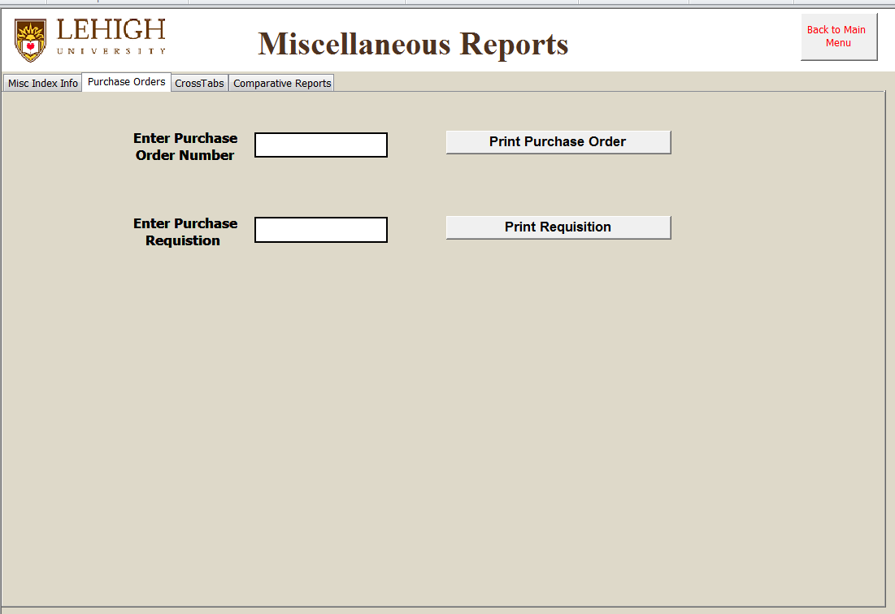

The second Miscellaneous Reports tab is labeled “Purchase Orders” and includes two reports that display information related to Purchase Orders and Requisitions entered in Banner. Information displayed includes vendor name, ship to address, item descriptions and Indexes charged.

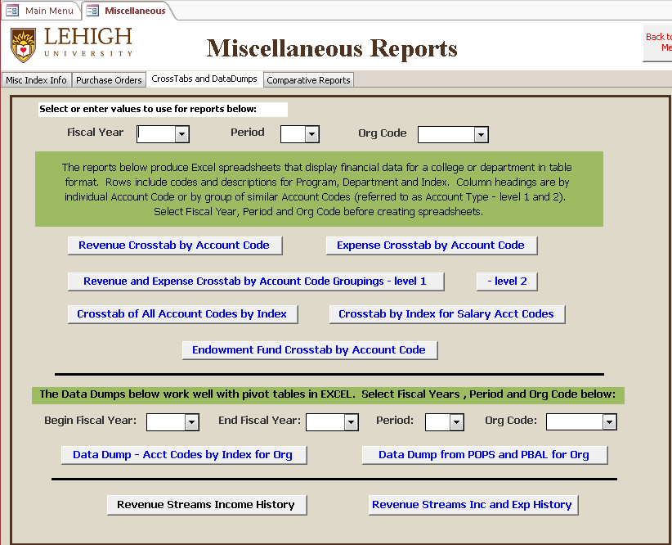

The third tab on the Miscellaneous Reports menu is labeled “Cross Tab Reports”.

These reports produce Excel spreadsheets that summarize and display financial data for a college or department in various ways. They were initially designed to assist a Business Manager of a College complete a survey of the College’s sources and uses of funds. Rows include codes and descriptions for Program, Department and Index. Column headings are by individual Account Code or by groups of similar Account Codes (referred to as Account Types).

The report labeled “Data Dump – Acct Codes by Index for Org” will create an Excel spreadsheet that you can then use to create various Excel pivot tables to summarize and analyze your data as needed.

Select Fiscal Year, Period and Org Code, then click on the desired spreadsheet report.
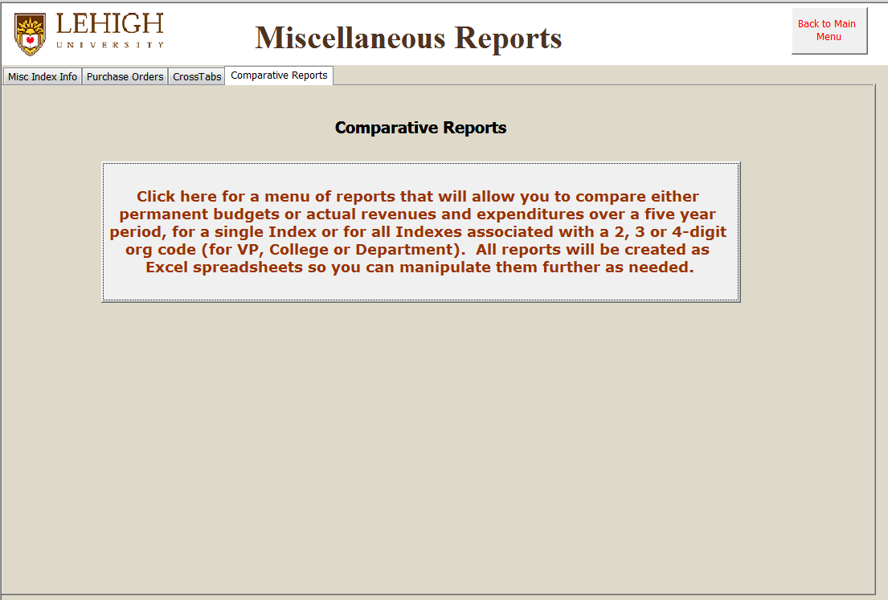

The fourth and final tab on the Miscellaneous Reports menu simply provides a link to a set of five-year comparative reports located on the last tab of the Budget Spreadsheets and Reports menu (see below).

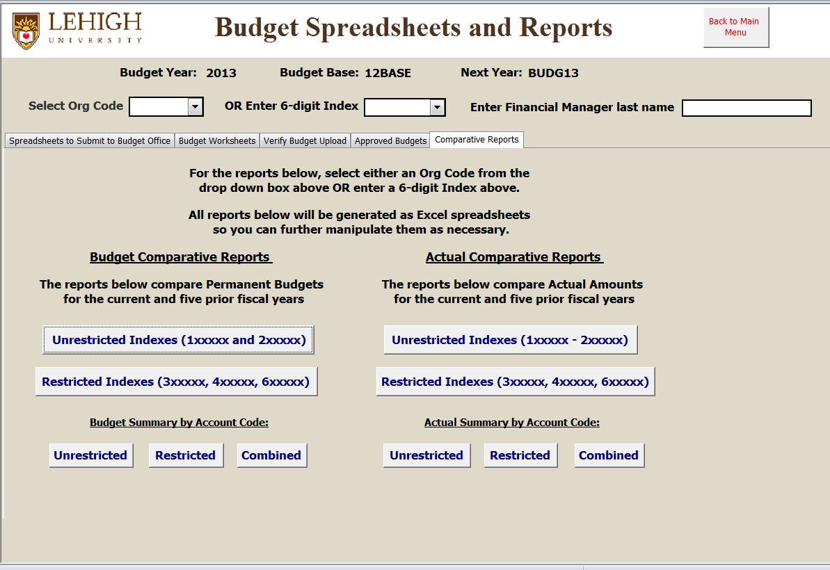

These comparative reports can be very useful in reviewing activity over time and in building future budgets based on past experience. All reports are created as Excel spreadsheets so you can easily review and manipulate as needed.

The reports on the left summarize budget activity while the reports on the right are for summarizing actual activity.

The first set of reports summarize by Index and those at the bottom summarize by Account Code for the Org Code selected above.

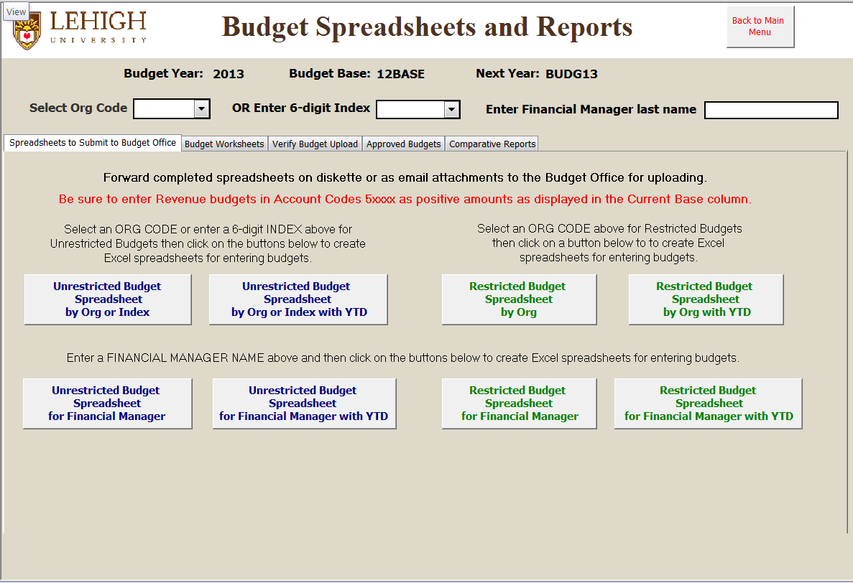

The Budget Spreadsheets and Reports menu is used primarily during the annual budget process.
This menu has five tabs. The first four tabs are ordered by how they are used in the budget process.

The last tab labeled “Comparative Reports” provides comparative reports of permanent budget and actual expenditures for the previous five fiscal years to assist managers in creating budgets for the new year.

The first tab labeled “Spreadsheets to Submit to Budget Office” includes reports that create Excel spreadsheets that can be used to enter new year budgets. Once completed, these spreadsheets can then be forwarded to the Budget Office for verification and upload into Banner.
Note that there are separate spreadsheets for Unrestricted Indexes (those that begin with 1 or 2) and Restricted Indexes (that begin with 3, 4, or 6).

Budget spreadsheets can be created for an entire organizational unit by selecting a 2, 3, or 4-digit org code for VP, College or Department. Or you can create separate spreadsheets for all or specific Financial Managers within you organizational unit which you can then send to them for completion.

Reports above that end with “YTD” include an extra column that displays the prior fiscal year’s actual activity which may assist in creating budgets for the new year. Either spreadsheet may be used and forwarded to the budget office for upload, however, separate spreadsheets must be submitted for Unrestricted and Restricted Indexes explained above.

All reports include comparative budget information for the current budget year.

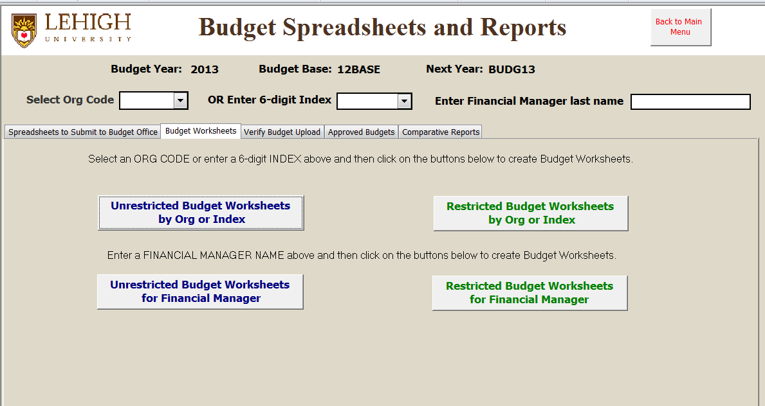

The second tab includes reports that create Budget Worksheets for a single Index or all Indexes associated with an org code or financial manager. These can be produced for all or specific Financial Managers within your organizational unit and sent to them for completion.

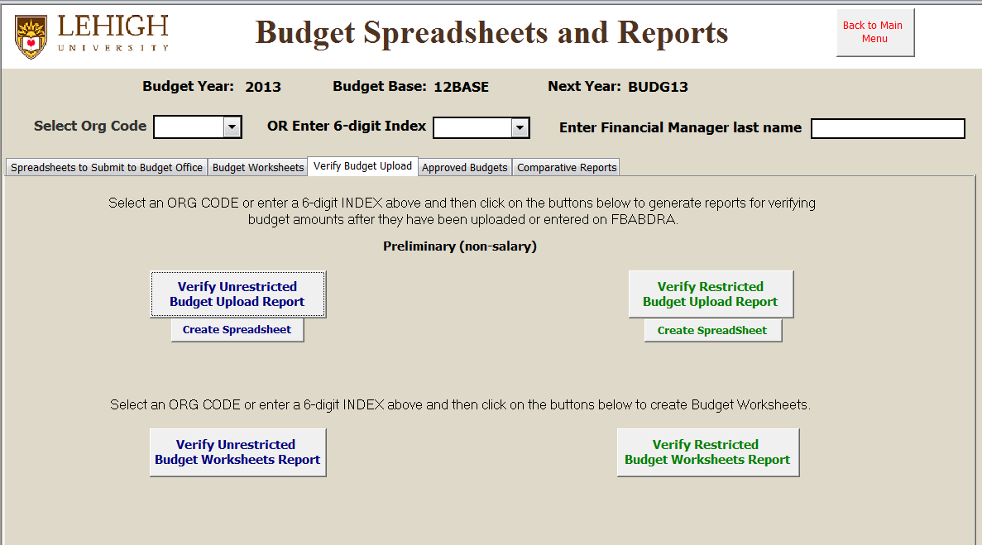

The tab labeled “Verify Budget Upload” includes reports you can use to verify non-salary budgets after they have been entered, either by data entry or via spreadsheets uploaded by the Budget Office.

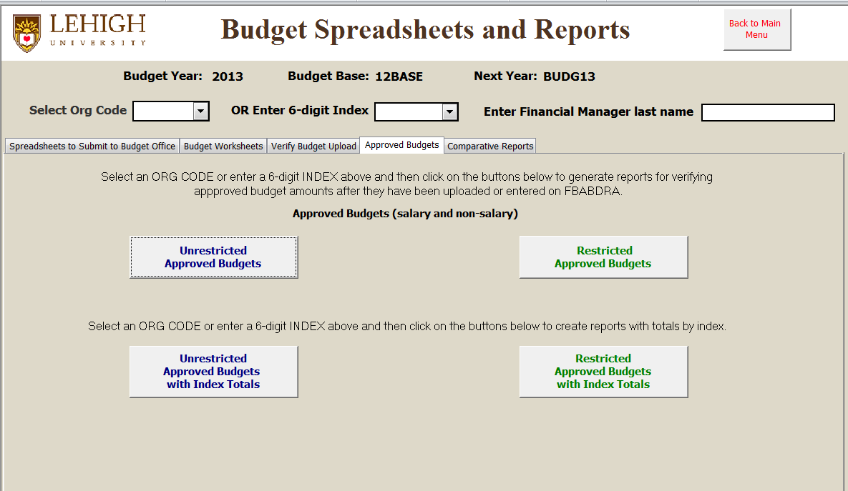

The tab labeled “Approved Budgets” includes reports that can be run at the end of the budget process to verify final approved budgets that include both salary and non-salary budgets.

Department Specific Reports for Office of Research and Sponsored Programs (ORSP)

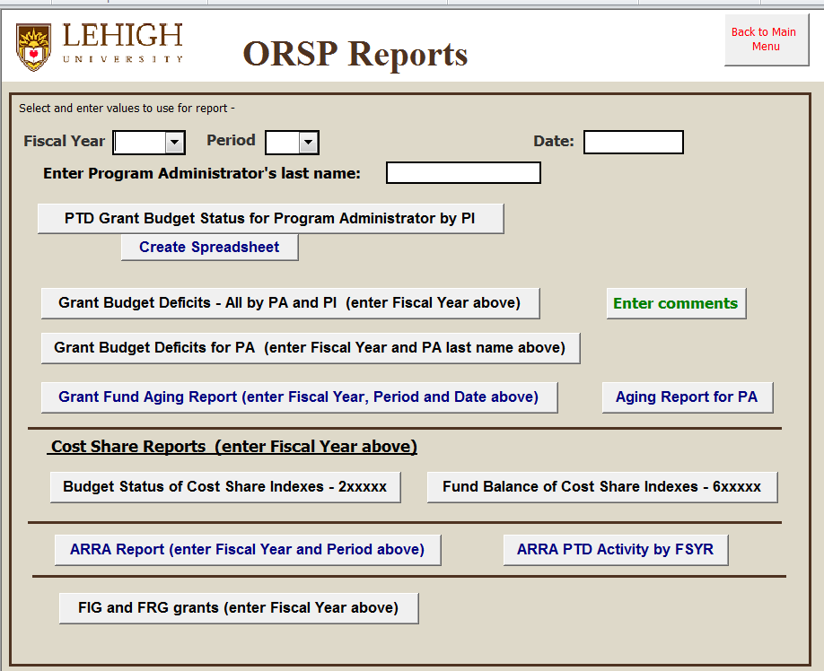

The menu of reports above are specifically designed to provide Program Administrators with the project to date budget status of grants for which they provide assistance to PI’s.

There are exception reports of Grant Budget Deficits that can be run for all grants or for grants associated with a single PA.

Enter comments allows PA’s to enter notes about grant status which subsequently appear on reports.

Grant Fund Aging reports list grants by Project End Date (oldest first) that are not yet terminated.

Cost Share reports list the budget status or fund balance of related cost share Indexes.

ARRA reports were created to monitor budget status and fiscal year activity of grants funded from stimulus funds.
How to install the Desktop Finance Reporting database on your pc…

The latest version of the Desktop Finance reporting database will always be stored in the directory J:\Banner\DesktopFinance. Each version is uniquely named “Desktop_Finance_dmrt_mmddyy.mdb” where mmddyy represents the date the version was modified. When you copy a new version to your desktop, it will not overwrite the previous version. Once you’re satisfied with the latest version, you can delete the previous one.

The quickest and easiest way to get a copy of the latest version of Desktop Finance is to click on “My Computer” and navigate to the directory J:\banner\DesktopFinance. Look for the file named Desktop_Finance_mmddyy.mdb with the most current mmddyy date and then simply copy and paste it to the desktop of your pc. You should then have a Microsoft Access icon on your desktop screen labeled Desktop_Finance_mmddyy.mdb

At this point, you should be ready to go. Simply double click on the icon when ready to use the database and Microsoft Access should open automatically. Each time you open the database, a login screen will appear. Enter the same User ID and Password you use to log into and access Banner. After you enter you password be sure to click on the box labeled “Click here to Login to Banner” to open the database.

Refer back to page 2 of this document for screen by screen descriptions of all reports available.

Enjoy!

