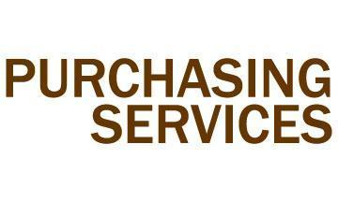
Business Plan
FY 2017-FY 2019

September 2, 2016
(Rev 10-25-16)

VISION

To be sought out as a valued partner to the Lehigh community by providing superior value-driven customer service, collaborative approaches to purchasing service programs and support through technology innovation and application of best practices.
MISSION

We assist our clients in obtaining products and services from appropriate sources at the lowest total cost and best overall value. We will serve as an exemplary steward of the University’s resources, striving to minimize risk, and create and maintain cooperative, integrated relationships and sound business practices.
GOALS

- Talent Management: Implement a talent management strategy to develop and improve employee engagement and performance

- Technology & Innovation: Collaborate with business partners and suppliers to drive innovation and develop, implement and administer programs needed to support the campus community (surplus property, diverse & local suppliers, OneCard, Unimarket, etc.)

- Metrics: Identify and begin to track meaningful and actionable department metrics that go beyond cost savings

- Communication: Improve communication within Purchasing to improve engagement, information flow, and performance, providing guidance to the campus on procurement related matters

- Collaboration/Client Experience: Focus on and constantly improve the client experience in daily interactions and in the programs and solutions we offer tot eh campus community. Through collaboration, outreach, and education, we work with the campus community to understand their needs and develop solutions that optimize value in their procurement needs.

SUCCESS FACTORS

Spend analysis |  | Strategic sourcing process
Supplier relationship management |  | Technology implementation
Developing project plans |  | Enterprise-wide contracts
Forecasting |  | Involvement in specification development
Process optimization |  | Supplier development
Work responsibility refinement |  | Garner stakeholder support

STANDARD OPERATING OBJECTIVES

- Program or service adoption & utilization (OneCard, Travel, Unimarket, LabStore, Office Supplies)
- Sourcing and contract activities (RFPs, LUCA, spend analysis)
- Continuous review of programs and services for metrics to capture as standard operative objectives.
DEFINING OBJECTIVES & STRATEGIES – FY 2017

- Talent Management: Support the F&A goal of implementing a talent management strategy to develop leaders and improve employee engagement and performance in order to sustain our work and equip our stem for future challenges and opportunities

Defining Objective: Develop a talent management program for purchasing team.
Metric: Policy approval and corresponding program and policy implementation
Strategies:

- Implement use of Performance Draft Book
- Review and update position descriptions, define what talent/skills are needed, gaps identified
- Develop professional development program for each purchasing team member for skill development
- Collaborate with colleagues on cross-department projects

 | Deadline | Resource Needs | Status
 | Ongoing FY17 | Pro-D funding | Performance Draft Book training; performed 3rd quarter team reviews early October; requested team review PD’s to ensure “big rocks” are captured in PD’s (jca 10/25/16)

- Technology: Advance the F&A goal of improving and enhancing business unit performance, security and customer service by expanding the use of technology in UBS business units.

Defining Objective: Implement UniMarket Sourcing module for Purchasing-led RFPs. This is one of 3 main functionality components to be implemented across the duration of this Strategic Plan.
Metric: 100% of purchasing-led RFPs being conducted through module by 12/31/16
Strategies:
- Develop in-depth understanding of module functionality
- Determine pilot group of vendors or departments or specific RFPs for pilot of module
- Roll out with purchasing, determine administrators within department
- Train other frequent user departments as applicable (LTS, Facilities)

 | Deadline | Resource Needs | Status
 | January 2017 | None | Launched July, 2016 for FY2017 RFPs published by Purchasing; identified hiccups in functionality, working with UM on solutions (spam, file size limits, registration issues, etc.) (jca10/25/16)

Defining Objective: Complete 100% campus implementation of the Unimarket Marketplace. This is one of 3 main functionality components to be implemented across the duration of this Strategic Plan.
Metric: Number of departments trained; system usage
Strategies:

- Create department training schedule (early adopters, other departments)
- Coordinate outreach of departments among purchasing administrators
- Establish division of responsibilities within purchasing administrators to facilitate implementations (training, workflow setup, user administration, catalog development, etc.)
- Marketing campaign to advertise program rollout and generate continued adoption
- Training Phase 2 to include Receiving

 | Deadline | Resource Needs | Status
 | May 2017 full campus implementation | None | Majority of departments have been trained with the exception of Engineering, scheduled for Fall 2016 (completed as of October 2016). Training video in development, geared toward faculty approvers for 12/31/16 rollout (jca 10/25/16)

- Metrics: Identify and begin to track meaningful and actionable metrics (ongoing, published monthly)

- Communication: Improve communication to improve engagement, information flow, and performance.

Defining Objective: Approval and publication of the Sustainable Purchasing Policy.
Metric: Policy approval and corresponding program and policy implementation
Strategies:

- Obtain endorsement of VP F&A, policy sponsor to leadership team and University officers
- Refine policy based on officer, leadership feedback
- Develop marketing campaign for broader university publication – websites, announcements, meetings, etc.

 | Deadline | Resource Needs | Status
 | December 31, 2016 | Minimal, possibly for customer incentives | Draft policy currently being reviewed by LEAG (jca 2/11/16)  Feedback has been gathered, edits compiles, ready to share with VP F&A and Leadership for approval (jca 8/8/16)  Sent to VP F&A and Provost October 21st for final review and approval (jca 10/25/16)

Defining Objective: Develop a surplus property program, inclusive of Asa’s Attic and in conjunction with Lehigh’s Waste Management Planning efforts and the Lehigh student capstone LV Shares project.
Metric: Program development and implementation
Strategies:

- Structured program to handle various types of surplus property, disposition of lab equipment, furniture, etc.
- Collaborating with Facilities and student capstone project, general counsel, controller’s office to develop LV Shares Program
- Policy development regarding Asa’s Attic process, and corresponding documentation
- Communications strategy to implement the various programs
- Metrics and reporting development across all programs

 | Deadline | Resource Needs | Status
 | Ongoing FY17 | Possible storage space, possible program administrator | Ongoing meetings started summer 2016 with students, facilities, and peer departments to research LV Shares and overall surplus property management strategies; incorporating Res Services process into program, as well as lab equipment considerations from EH&S into process; notified by students October 2016 that 3 of the 4 students are leaving the Capstone Project and recruitment underway for replacements (jca 10/25/16)

DEFINING OBJECTIVES & STRATEGIES – FY 2018

- Talent Management: Support the F&A goal of implementing a talent management strategy to develop leaders and improve employee engagement and performance in order to sustain our work and equip our stem for future challenges and opportunities

- Technology: Advance the F&A goal of improving and enhancing business unit performance, security and customer service by expanding the use of technology in Purchasing Services.

Defining Objective: Complete analysis of copier lease program (university vs department).
Metric: Copiers eliminated; combined leases under consolidated contracts; savings
Strategies:

- Identify campus opportunity…copier inventory, lease expiration timelines, warranty, etc.
- Review financial implications and models
- Negotiate new contracts, lease management program as necessary (department, campus, etc.)
- Streamlining invoicing process

 | Deadline | Resource Needs | Status
 | FY 2017 launch and completion | None | Project plan development with Linda Roberts for Fall 2016, ongoing monthly meetings with Ricoh, Purchasing and A/P to devise solution (jca 10/25/16)

Defining Objective: Expand utilization of UniMarket Contracts module to other departments (LTS, OGC, ORSP to start). This is one of 3 main functionality components to be implemented across the duration of this Strategic Plan.
Metric: Departments using system
Strategies:
- Module demonstration and training for other departments
- Pilot module usage, report and audit features
- Continue functionality development opportunities with Unimarket team
- Expand implementation as applicable

 | Deadline | Resource Needs | Status
 | FY 2017 | None

- Metrics: Identify and begin to track meaningful and actionable metrics for the department (ongoing, published monthly).

Defining Objective: Implement early phase activities in development of a Diverse and Local Supplier Program.
Metric: Certified vendors, survey publication
Strategies:

- Current vendor communications and certification information collection for Banner and Unimarket
- Identification of diversity criteria to track and means to do so in current systems, establishing baselines

 | Deadline | Resource Needs | Status
 | FY 2017 | None

Defining Objective: OneCard Out of Pocket (OOP) spend and opportunity analysis. This is one element of a multi-pronged approach to expanding the implementation of the OneCard Program and enhancing functionality adoption across the campus community.

Metric: OOP users converted to OneCards; spend/person
Strategies:
- Consolidate various data sources, compile detailed reporting at line item/commodity level, leakage
- Identify opportunities to consolidate spend, reduce supply base, develop catalogs, etc.
- Department outreach

 | Deadline | Resource Needs | Status
 | FY 2017 | None | Project areas to be identified for program administrators (jca 8/8/16)

- Communication: Improve communication to improve engagement, information flow, and performance.

Defining Objective: Completion of Environmentally Preferable Products (EPP) sustainability substitutions specific to LabStore inventory.
Metric: Program implementation (gloves, pipettes, conversion of hot list items)
Strategies:

- Project plan development and division of responsibilities among student employees
- Conduct EPP research on inventory items, oversee ongoing project, propose inventory changes
- Communications to lab customers regarding changes

 | Deadline | Resource Needs | Status
 | FY 2017 launch and implement | None | Project development for Sharon, next steps on EPP versus recycle program with vendors (that want to charge) (jca 8/8/16)

DEFINING OBJECTIVES & STRATEGIES – FY 2019

- Talent Management: Support the F&A goal of implementing a talent management strategy to develop leaders and improve employee engagement and performance in order to sustain our work and equip our stem for future challenges and opportunities

- Technology: Advance the F&A goal of improving and enhancing business unit performance, security and customer service by expanding the use of technology in Purchasing Services.

Defining Objective: Service Electric – web based activation/de-activation/inventory program management FY 2019.
Metric: TBD
Strategies:
- Finalize campus connection inventory, department owners
- Investigate web-based forms/means of activation/de-activation functionality
- Creation of new process
- Marketing to campus

- Metrics: Identify and begin to track meaningful and actionable metrics for the department.

- Communication: Improve communication to improve engagement, information flow, and performance.

Defining Objective: Develop Supplier Relationship Management Program with Tier 1 vendors, particularly in Facilities Services (apply 80/20 rule) FY 2019.
Metric: TBD
Strategies:
- Identify vendors that comprise 80% of spend
- Identify key stakeholders/potential customers, established formalized program review (ongoing schedule)
- Spend / opportunity analysis, performance scorecard, innovation, long term relationship management

Lehigh University’s annual budget is a planning tool, which becomes the financial roadmap to support the overall strategic plan. This links the strategic plan by converting it into actual funding sources and uses. In order to fully implement the strategic plan, identification and planning of capital and resource requirements is critical.
CAPITAL & RESOURCE REQUIREMENTS

University Business Services places high value on long-range planning in order to provide the appropriate services to Lehigh and the surrounding community. Each of the UBS departments submits capital and resource funding recommendations to senior leadership annually based on ongoing and newly identified service needs. Senior leadership evaluates and prioritizes funding requests based on need and available funds across the stem. UBS capital and resource plans are finalized each spring and are included in the university’s overall annual budget. The university fiscal year begins July 1st.
As individual departments begin the annual budget review process, care is taken to develop means of providing incremental revenues for established service programs, or reducing expenses in order to free up existing funds to support other programs
For the purposes of this document, capital budget relates to investments in large-dollar projects undertaken either to acquire or to construct assets such as building or buses, typically valued at $500,000 or greater. These projects are typically funded from reserves, a special allocation or partially from the annual operating budget.
University Business Services is comprised of ten individual business units. This document defines the plans for each department, with a brief description for each.
Business units include:
Printing & Mailing Services Purchasing Services
Transportation Services Trademarks & Licensing
Parking Services The Mail Center
University Bookstore Real Estate Services
Office of Sustainability Farrington Square
LabStore Farmer’s Market
Copy Center Warehouse

Each department prepares its own capital and resource recommendations. Recommendations were submitted in FY 2014, with needs projected through FY 2020, and updated annually as unforeseen needs arise. UBS capital and resource requests are classified into the following categories as well as one-time versus permanent funding.
- Products
- Services
- Software
- Equipment
- Leases
- Human Resources
- Other
PURCHASING SERVICES

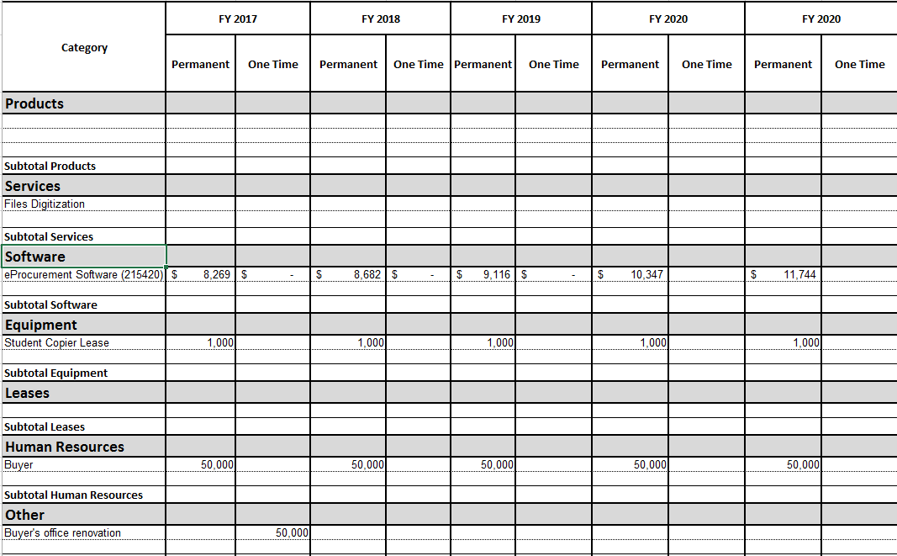

Funding Classification Request Details:

1. Products
2. Services
3. Software
eProcurement Software
$8,269 w/3% annual increase, permanent
Funded: Yes__X__ No ____
Year Funded: 2015
Funding Source: Purchasing budget
Priority Level: A
Description/Background/Rationale: eProcurement software system, user friendly front end system to Banner for requisition entry and PO creation; additional modules supporting RFP process, contracts database, receiving and invoicing
- Equipment
Student Copier Lease
$1,000 one time
Funded: Yes____ No __X__
Funding Source:
Priority Level: C
Description/Background/Rationale: Not needed, utilize copier in Purchasing
- Leases
- Human Resources
Buyer
$50,000 one time
Funded: Yes____ No __X__
Year Funded:
Funding Source:
Priority Level: B
Description/Background/Rationale: additional resource needed to support ongoing purchasing programs such as Diverse/Local Supplier Program, Surplus Property, RFP process, and contract reviews
- Other
Buyer’s Office Renovation/Build-out
$50,000 one time
Funded: Yes____ No __X__
Year Funded:
Funding Source:
Priority Level: B
Description/Background/Rationale: Purchasing office currently has no space available for an additional staff member. Renovation would be required, as well as furniture and technology, to support the new position

Prioritization Legend:
Level A: Contracted, legally obligated
Level B: ROI or re-allocated
Level C: Generally supports UBS, F&A, University Goals

