- Go to www.concursolutions.com and log in with your username and password. Your username should be your Lehigh University email address. If you do not know your password, please contact Brenda Bachman at 610-758-3266 or via email at bkb204@lehigh.edu to have it reset. 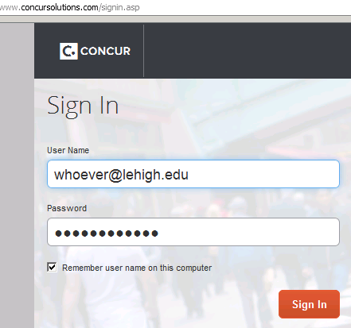
- Once logged in, please click on Profile in the upper right corner, and then on Profile Settings.
- This brings up the following page entitled Profile Options. Click on Credit Card Information. 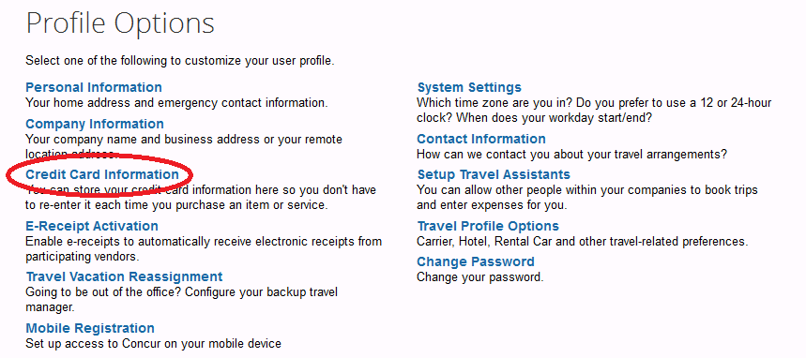
- This links you to the credit card information area of your Concur Travel profile. From here, click on Add a Credit Card. 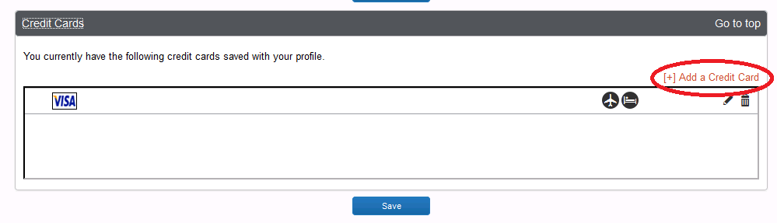

- This brings up a pop up window as displayed below. Please complete all fields marked in red and click Save at the bottom.
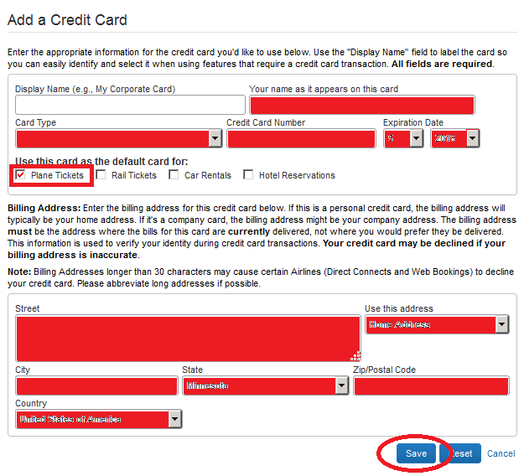
- Upon clicking save the pop up window closes and you will return to the credit card area of your Concur Travel profile. Please click Save here now as shown below. 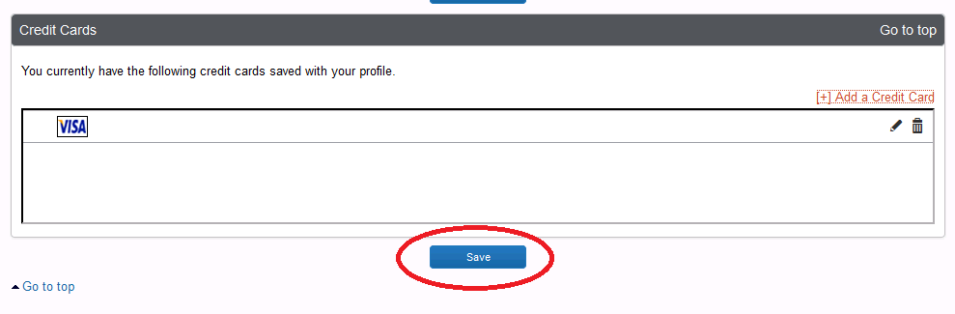
- You will then notice a notation indicating that your profile has been saved.
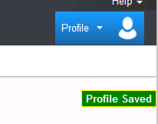
- You are now finished and can log out of Concur Travel by clicking on Profile, Sign out. 